<Survive Against Enemies (S.A.E)>
  - CIST2740-201601-21362: game concept document
PREPARED BY: LEANN TRINH
The closer you get to freedom, the more dangerous survival becomes.
GTC Game Studios
Tel 770-9627580  Web http://www.gwinnetttech.edu | 5150 Sugarloaf Pkwy, Lawrenceville, GA 30043  Copyright © 2016 All rights reserved, Clinton A. Lowe, Gwinnett Technical College, and CIST2740 Alumni | [Version]

Contents
Game Summary 1
Product Summary 3
Marketing Summary 4
Competitive Analysis 7
Proof of Concept 8
Prospective Publishers 8
Financial Analysis 9
Financial Statements 10
Development Team 11
Company Information 11

Game Summary

High Concept
Your mission begins when you wake up inside a laboratory that has sealed itself completely. The facility has turned into a dangerous zone because its experiments have resulted in genetically modified monsters which have escaped their intended boundaries. You take on the role of a survivor who must find his way to safety but the exit path becomes increasingly dangerous because of the monsters that emerge to prevent your escape from the facility.

The first level of the game begins with low tension which increases throughout the game until players must use their strategic thinking abilities and limited resources to stay alive. Your mission goes beyond escaping the facility because you need to discover the outbreak source and understand how the creatures become stronger when you approach freedom.

The survival horror experience creates an environment where players must battle both environmental factors and enemy threats while solving a mystery which prevents their progress toward the exit.

Premise and Story Synopsis
The player is stuck in a laboratory and must fight their way out. However, in this laboratory, it’s infested with creatures genetically modified caused by the failed experiments that took place. The farther the player gets to the exit, the creatures they face gets stronger almost like they don’t want you to leave. The player will come across the creatures, some are easy, some are difficult, but can the player reach their way out?
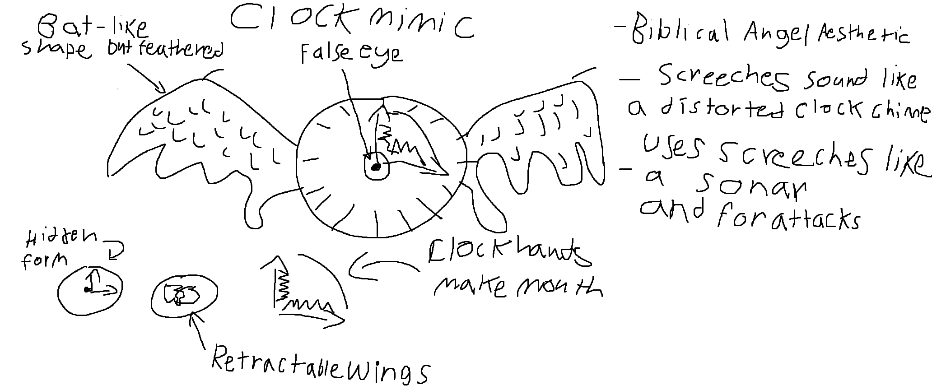
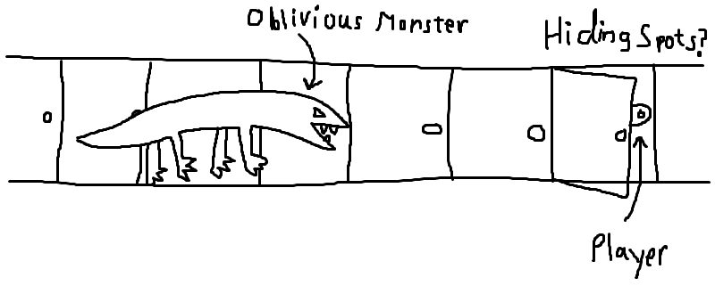

License
Gwinnett Technical College, Clinton A. Lowe, and CIST2740 Course Alumni are joint owners of the intellectual property defined herein with mutual, non-exclusive worldwide rights and all rights reserved.

Studio Contact
Interested publishers and investors can contact us with our team’s email address. They will have to contact our team lead who is:
Kameron Wade
Team Lead
770-9627580

Product Summary

Genre

The game is a survival horror experience while including additional components of action and adventure gameplay. The Entertainment Software Association (ESA) states that video games fall into major game categories which include action and adventure as two of the most popular market segments.

The game uses survival horror elements together with action and adventure gameplay to match current industry trends which successful games adopt by combining different game types while keeping a strong central theme.

Unique Selling Points

The game’s unique selling points include its escalating difficulty system, which makes enemies stronger when players attempt to leave. The game includes various enemy mutations, which introduce new combat patterns and visual changes that create unpredictable battle situations. The game forces players to manage their limited resources because they need to survive through their survival-based missions. The environmental storytelling and logs and hidden clues enable players to discover the laboratory's secrets. The game creates an immersive horror experience through its use of dynamic lighting and sound design and atmospheric environments.

Features

Characters & Props
The enemy the player first interacts with is Rusher who comes at you in full speed. Rusher comes in waves of two, however is relatively easy to defeat. The reward after defeat is being able to continue on escaping.
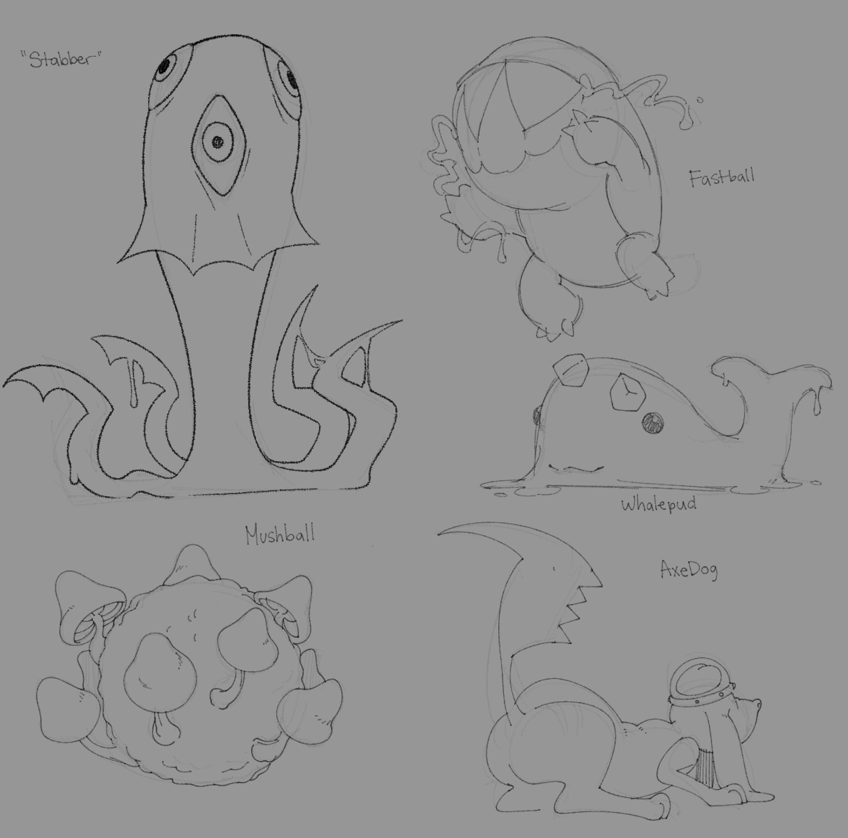

Game Mechanics
The game’s unique selling points include its escalating difficulty system, which makes enemies stronger when players attempt to leave. The game includes various enemy mutations, which introduce new combat patterns and visual changes that create unpredictable battle situations. The game forces players to manage their limited resources because they need to survive through their survival-based missions. The environmental storytelling and logs and hidden clues enable players to discover the laboratory's secrets. The game creates an immersive horror experience through its use of dynamic lighting and sound design and atmospheric environments.

Levels, Puzzles, Challenges, and Quests
The game consists of multiple puzzle types and challenge types which include environmental puzzles and logic-based tasks and exploration objectives and survival scenarios. The initial game levels present basic puzzles together with weak enemies which assist players in mastering game mechanics whereas the subsequent game levels present intricate puzzles that require multiple steps to solve and strong opponents who display aggressive combat behavior.

The game becomes more difficult because enemies become stronger and players receive fewer resources and opponents present greater dangers. The exit approach leads to stronger enemies who exhibit unpredictable behavior together with resource depletion and increased challenge levels. The primary objective of the game requires players to escape from the laboratory while they complete secondary objectives which involve system restoration and area unlocking and outbreak story discovery. The game establishes a progression system that leads to increasing tension and difficulty changes which continue throughout the entire game experience.
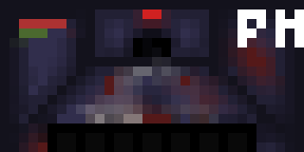

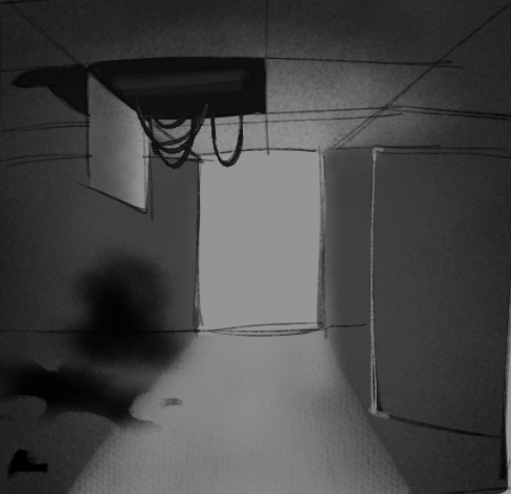

Marketing Summary

Target Market
Our game targets core gamers aged 18–34 who enjoy survival horror and action-based gameplay. The Entertainment Software Association reports that approximately 205 million Americans play video games with an average age of 36 and a nearly equal gender distribution. The U.S. video game industry generated about $60.7 billion in revenue in 2025.

The target audience for survival horror games generates approximately 10% of total gaming revenue which amounts to about $6.07 billion because survival horror exists as a specialized market segment. The horror game market maintains a competitive environment because 20 to 40 new horror games compete for market share each year while the market remains stable.

The game needs to capture between 1% and 3% of this niche market in order to generate estimated revenues between $60 million and $180 million through its success and marketing reach and player reception.

Target Rating
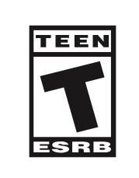
The Entertainment Software Rating Board (ESRB) will most likely assign a Teen (T) rating to the game because it contains violent content and suspenseful horror elements without showing explicit realistic gore. The player fights genetically mutated creatures in a laboratory setting which qualifies as fantasy or science fiction violence because it does not show actual human combat.

The game needs to limit bloodshed and stop showing graphic injury scenes and dismemberment and extended violent content to achieve a Teen rating from ESRB. The horror elements should rely on atmosphere, tension, and environmental storytelling rather than explicit or disturbing imagery. The content needs to stay free from strong language and sexual content.

The game receives a Teen rating because it contains non-realistic enemies and shows minimal blood effects while focusing on survival and escape. The game achieves a Teen-friendly horror experience by using suspense and strategic gameplay to deliver an exciting horror experience without showing explicit violent content.

Target Platform & Hardware Requirements

The best platform for our project work is PC and laptops because these devices create the ideal conditions for delivering an immersive survival horror experience. The high-quality graphics together with advanced lighting systems and detailed environments of PCs create the necessary components to establish the tense atmosphere of a laboratory that contains mutated creatures. The combination of keyboard and mouse controls enables players to achieve better precision while they control their characters during intense gameplay moments.

The PC platform suits our target audience of core gamers who play horror and survival games through Steam and the Epic Games Store. PC systems create flexible performance options because they allow the game to function on devices that range from high-performance machines to typical consumer-grade equipment. The combination of PC and laptop systems delivers the most effective and user-friendly gaming experience for our game.

Marketing Strategy
The game supports suspenseful marketing methods which create tension through mysterious elements. The survival horror game requires marketing to showcase its atmospheric qualities while providing minimal details and showing content incrementally to attract players. The company will achieve distribution and visibility through business relationships with Steam and Epic Games Store while YouTube creators and Twitch streamers will create exposure through their gameplay reactions. The gaming media outlets IGN and GameSpot will provide both previews and reviews. Digital platforms TikTok Instagram and Reddit serve as the most effective channels to connect with the target audience because short-form horror content and viral gameplay clips attract viewer attention. The marketing campaign will use a planned release schedule which starts with a teaser trailer 6 to 8 months before the launch and continues with gameplay and story trailers until it reaches the final launch trailer. The additional promotional elements will consist of screenshots concept art demos beta testing opportunities press releases developer interviews and social media campaigns. The marketing strategy which contains multiple phases will create excitement while engaging the target audience and achieving maximum visibility before the game release.

Competitive Analysis

Comparison #1: <Resident Evil Remake 2>
- Both games are survival horror experiences set in enclosed environments with limited resources, strong enemies, and a focus on escape and exploration.
- Developed by Capcom
Resident Evil Village (2021)
Resident Evil 7: Biohazard (2017)
- Launched at $59.99
- Over 10 million copies sold, indicating a large player base
- ~10+ million units

Comparison #2: <Outlast>
- Both emphasize fear, tension, and escaping a dangerous facility, with limited resources and strong enemy presence.
- Developed by Red Barrels
Outlast 2 (2017)
The Outlast Trials (2023)
- Around $19.99–$29.99
- Millions of players across PC and console platforms
- Estimated 15+ million copies across the series

Comparison #3: <SCP: Containment Breach>
- Focuses on mutated enemies, sci-fi horror setting, and survival mechanics, similar to the laboratory concept.
- Developed by Striking Distance Studios
(Founded by a creator of Dead Space)
- Launched at $59.99–$69.99
- Moderate player base (millions, but lower than expected AAA performance)
- Estimated ~2 million copies

Proof of Concept
At this stage of development, a proof of concept has not yet been developed. The project is currently in the conceptual and design phase, with core mechanics and features still being planned and outlined.

Prospective Publishers
The game needs to find publishers who include Blumhouse Games, Annapurna Interactive, New Blood Interactive, and Spiral Up Games as potential partners. Blumhouse Games would be especially interested because it focuses specifically on horror titles and seeks unique, low-budget concepts with strong impact. The company Annapurna Interactive shows interest because it develops innovative story-driven indie games. New Blood Interactive publishes indie horror games and action games that use different mechanics which makes the company suitable for this project. Spiral Up Games specializes in publishing indie PC titles and provides funding and marketing support which matches the game requirements.

These publishers have released similar games such as Fear the Spotlight, Stray, DUSK, and other indie titles that emphasize atmosphere, storytelling, and gameplay innovation. Publishers normally provide their contact details on their official websites which developers use to submit game proposals and to send business inquiries through dedicated forms.

Financial Analysis

Revenue
The game will be released on PC via Steam.
- Estimated price per unit: $24.99
- Estimated units sold (Year 1): 100,000 copies
- Estimated in-game purchases: Minimal (not focus of game)
Total Revenue Calculation:
- Game sales:
100,000 × $24.99 ≈ $2,499,000
- Platform fee (~30% Steam cut):
-$749,700
Net Revenue:
≈ $1,749,300

Expenses
Development Costs:
- Team salaries (small indie team): $500,000
- Software & tools: $25,000
- Hardware & equipment: $20,000
Marketing Costs:
- Ads, trailers, promotion: $150,000
- Influencer/streamer partnerships: $75,000

Other Costs:
- Legal & licensing: $30,000
- Miscellaneous: $25,000
Total Expenses:
≈ $825,000

Net Profit
Profit Calculation:
- Net Revenue: $1,749,300
- Expenses: $825,000
Estimated Net Profit:
≈ $924,300

Financial Statements

Statement of Financial Position
- Liabilities: Development and marketing costs ($825K)
- Assets: Revenue generated ($1.75M)
- Equity: ~$924K

Statement of Comprehensive Income (Profits and Losses)
- Income: $1,749,300
- Expenses: $825,000
- Profit: $924,300

Statement of Changes in Equity
Well, it wouldn’t be an annual report without a lot of numbers, right? This section is the place for all those financial tables.
To get started with a table that looks just like the sample here, on the Insert tab, click Tables, then choose Quick Tables.
Description | Revenue | Expenses | Earnings
Conservative Case | $1,749,300 | $825,000 | $924,300
Best Case (1%) | $60,000,000 | $10,000,000 | $50,000,000
Best Case (3%) | $180,000,000 | $25,000,000 | $155,000,000

Statement of Cash Flows
- Operating: Game sales revenue
- Investing: Development costs
- Financing: Initial funding/investment

Development Team

Key Team Members
Identify the development team members who are already committed to the project. Provide a brief bio for each teammate focusing on previous experience.
 | Kameron  Leader  Headlined the project |  | Gabriel  Designer  Made concept art and wrote documents for the game.
 | Brain  Assistant Headliner  Helped Kameron monitor the group

Staffing Plan
The project will need a development team which will consist of 10 to 15 members who will work in various roles. The producer or project manager will maintain control of the project from start to end during its 40-week duration. The game designer and narrative designer will establish core mechanics and story elements during pre-production which lasts from week 1 to week 8.

The production phase which lasts from week 9 to week 32 will see team members expand to include 3 to 4 programmers an AI programmer 2 to 3 environment artists 1 to 2 character artists 1 to 2 animators and a UI/UX designer. The team will develop gameplay systems while creating assets and executing essential features.

The final phase which lasts from week 30 to week 40 will bring in QA testers and a sound designer who will help test and improve the game. The structured approach of this system helps develop all major game development aspects while maintaining resource efficiency.

Company Information
GTC Game Studios

5150 Sugarloaf Pkwy, Lawrenceville, GA 30043
Tel 770-9627580
Web gwinetttech.edu

